Implementation

In this phase the designs are translated into code. Computer programs are written using a conventional programming language or an application generator. Programming tools like Compilers, Interpreters, Debuggers are used to generate the code. Different high level programming languages like C, C++, Pascal, Java are used for coding. With respect to the type of application, the right programming language is chosen.

The development stage takes as its primary input the design elements described in
the approved design document. For each design element, a set of one or more
software artifacts will be produced. Software artifacts include but are not limited
to menus, dialogs, data management forms, data reporting formats, and
specialized procedures and functions. Appropriate test cases will be developed
for each set of functionally related software artifacts, and an online help system
will be developed to guide users in their interactions with the software.
A product software implementation method is a blueprint to get users and/or organizations running with a specific software product. The method is a set of rules and views to cope with the most common issues that occur when implementing a software product: business alignment from the organizational view and acceptance from the human view.
The implementation of product software, as the final link in the deployment chain of software production, is in a financial perspective of a major issue.
The complexity of implementing product software differs on several issues. Examples are: the number of end users that will use the product software, the effects that the implementation has on changes of tasks and responsibilities for the end user, the culture and the integrity of the organization where the software is going to be used and the budget available for acquiring product software.
The implementation of our project is done by choosing the front-end as JAVA and back-end as Microsoft SQL (MS Access). It requires a Computer as a Hardware & jdk1.5 and MS Access as software.

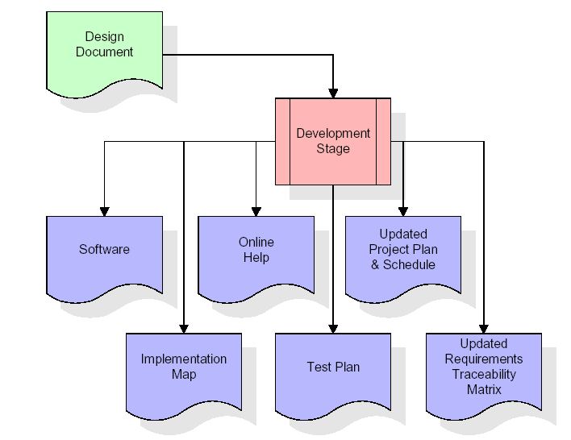
The RTM will be updated to show that each developed artifact is linked to a
specific design element, and that each developed artifact has one or more
corresponding test case items. At this point, the RTM is in its final configuration.
The outputs of the development stage include a fully functional set of software
that satisfies the requirements and design elements previously documented, an
online help system that describes the operation of the software, an implementation
map that identifies the primary code entry points for all major system functions, a
test plan that describes the test cases to be used to validate the correctness and
completeness of the software, an updated RTM, and an updated project plan.

SYSTEM REQUIREMENTS
The system services and goals are established by consultation with system user. They are then defined in details and serve as a system specification. System requirements are those on which the system runs.
Hardware requirements:
- Computer with either Intel Pentium processor or AMD processor.
- 128 MB DDR ram
- 20 GB HDD
Software requirements:
- Windows 98/2000/Xp operating system.
- Microsoft Office package.
- JAVA development kit Version 1.5 (jdk1.5)

Here is a sample of the code used in the main class. The code depicts the actions performed on clicking a button.

public void actionPerformed(ActionEvent e)
{
if(e.getSource()==b1)
{
d.setVisible(true);
}

if(e.getSource()==b2)
{
f.dispose();
Documentation dt=new Documentation();
}

if(e.getSource()==b3)
{
f.dispose();
Credits cs=new Credits();
}

if(e.getSource()==b4)
{
f.dispose();
Enter et=new Enter();
}

if(e.getSource()==b5)
{
f.dispose();
Retrieve rt=new Retrieve();
}

if(e.getSource()==b6)
{
f.dispose();
System.exit(0);
}

if(e.getSource()==b7)
{
d1.dispose();
}
}

